**Q1)** Identify the Data type for the Following:

|  |  |
| --- | --- |
| Activity | Data Type |
| Number of beatings from Wife | Discrete |
| Results of rolling a dice | Discrete |
| Weight of a person | Continuous |
| Weight of Gold | Continuous |
| Distance between two places | Continuous |
| Length of a leaf | Continuous |
| Dog's weight | Continuous |
| Blue Color | Discrete |
| Number of kids | Discrete |
| Number of tickets in Indian railways | Discrete |
| Number of times married | Discrete |
| Gender (Male or Female) | Discrete |

**Q2)** Identify the Data types, which were among the following

Nominal, Ordinal, Interval, Ratio.

|  |  |
| --- | --- |
| Data | Data Type |
| Gender | Nominal |
| High School Class Ranking | Ordinal |
| Celsius Temperature | Ratio |
| Weight | Interval |
| Hair Color | Nominal |
| Socioeconomic Status | Nominal |
| Fahrenheit Temperature | Ratio |
| Height | Interval |
| Type of living accommodation | Ordinal |
| Level of Agreement | Nominal |
| IQ(Intelligence Scale) | Interval |
| Sales Figures | Interval |
| Blood Group | Nominal |
| Time Of Day | Ordinal |
| Time on a Clock with Hands | Nominal |
| Number of Children | Nominal |
| Religious Preference | Ordinal |
| Barometer Pressure | Ration |
| SAT Scores | Interval |
| Years of Education | Interval |

**Q3)** Three Coins are tossed, find the probability that two heads and one tail are obtained?

ANS: Three coins are tossed means total set = {(H,H,H),(H,H,T),(H,T,T),(T,T,T),(T,H,H),(T,H,T),(T,T,H),(H,T,H)} = 8

Probability for two heads and one tail are obtained is let’s say set A= {(H, H, T), (T, H, H), (H, T, H)} = 3

P (A) = Elements of A / Total no of outcomes = 3/8

**So P(A)=3/8**

**Q4)** Two Dice are rolled, find the probability that sum is

1. Equal to 1
2. Less than or equal to 4
3. Sum is divisible by 2 and 3

ANS: Total outcomes for the two dice are rolled are: {(1,1),(1,2),(1,3),(1,4),(1,5),(1,6), (2,1),(2,2),(2,3),(2,4),(2,5),(2,6), (3,1),(3,2),(3,3),(3,4),(3,5),(3,6), (4,1),(4,2),(4,3),(4,4),(4,5),(4,6), (5,1),(5,2),(5,3),(5,4),(5,5),(5,6), (6,1),(6,2),(6,3),(6,4),(6,5),(6,6)}

Total possible outcome = **6x6 =36**

a)  Favourable outcome (sum equal to 1)**= 0**{i.e. not possible that sum always exceed to 1}

Required probability = P(A) = A/N = **0/36 = 0**

b)  Favourable outcome(sum equal to 4) **= 3**{i.e. (1, 3) (2, 2) (3, 1)}

Required probability = P(B) =B/N = **6/36 =1/6**

c)Sum is divisible by 2 and 3 = Roll two dice, there are 36 possible outcomes, ranging from 2 to 12.

So Elements of C i.e. C = 6

P(C) = C/N = 6/36 = 1/6

**Q5)** A bag contains 2 red, 3 green and 2 blue balls. Two balls are drawn at random. What is the probability that none of the balls drawn is blue?

ANS: There are 7 balls originally with 2 of them blue so the probability of the first ball not being blue is 5/7. This leaves 6 balls with 2 blue. The probability of the second ball not being blue assuming that the first wasn’t is 4/6. The probability that neither ball drawn was blue is **(5/7)*(4/6) =20/42 = 10/21**

**Q6)** Calculate the Expected number of candies for a randomly selected child

Below are the probabilities of count of candies for children (ignoring the nature of the child-Generalized view)

|  |  |  |
| --- | --- | --- |
| CHILD | Candies count | Probability |
| A | 1 | 0.015 |
| B | 4 | 0.20 |
| C | 3 | 0.65 |
| D | 5 | 0.005 |
| E | 6 | 0.01 |
| F | 2 | 0.120 |

Child A – probability of having 1 candy = 0.015.

Child B – probability of having 4 candies = 0.20

ANS: Expected number of candies for a randomly selected child

= 1 * 0.015 + 4*0.20 + 3 *0.65 + 5*0.005 + 6 *0.01 + 2 * 0.12

= 0.015 + 0.8 + 1.95 + 0.025 + 0.06 + 0.24

= 3.090

**= 3.09**

**Q7)** Calculate Mean, Median, Mode, Variance, Standard Deviation, Range & comment about the values / draw inferences, for the given dataset

* For Points,Score,Weigh>

Find Mean, Median, Mode, Variance, Standard Deviation, and Range and also Comment about the values/ Draw some inferences.

**Use Q7.csv file**

ANS:

|  |  |  |  |
| --- | --- | --- | --- |
|  | **Points** | **Score** | **Weigh** |
| **Mean** | 3.5965625 | 3.21725 | 17.84875 |
| **Median** | 3.695 | 3.325 | 17.71 |
| **Mode** | 3.07 and 3.92 | 3.44 | 18.9 and 17.2 |
| **Variance** | 0.285881351 | 0.957379 | 3.193166129 |
| **standard deviation** | 0.534678736 | 0.978457 | 1.786943236 |
| **Range** | 2.76,4.93 | 1.513,5.424 | 14.5,22.9 |

(Refer assignment.ipynb file Q-7)

**Q8)** Calculate Expected Value for the problem below

1. The weights (X) of patients at a clinic (in pounds), are

108, 110, 123, 134, 135, 145, 167, 187, 199

Assume one of the patients is chosen at random. What is the Expected Value of the Weight of that patient?

ANS: Expected Value = ∑ (probability * Value)

 ∑ P(x).E(x)

There are 9 patients

Probability of selecting each patient = 1/9

Ex 108, 110, 123, 134, 135, 145, 167, 187, 199

P(x) 1/9 1/9   1/9 1/9   1/9   1/9   1/9   1/9 1/9

Expected Value = (1/9) (108) + (1/9)110 + (1/9)123 + (1/9)134 + (1/9)135 + (1/9)145 + (1/9(167) + (1/9)187 + (1/9)199

= (1/9) (108 + 110 + 123 + 134 + 135 + 145 + 167 + 187 + 199)

= (1/9) (1308)

= 145.33

Expected Value of the Weight of that patient = **145.33**

**Q9) Calculate Skewness, Kurtosis & draw inferences on the following data**

**Cars speed and distance**

**Use Q9_a.csv**

**ANS:**

|  |  |  |
| --- | --- | --- |
| Parameter | Cars Speed | Cars distance |
| Skewness | -0.1139 | 0.7824 |
| Kurtosis | 2.422 | 3.248 |

Refer assignments.ipynb Q9B

Inference: Cars speed skewness is negative it implies that the mass is distributed on the right side whereas Cars distance skewness is positive it implies that the mass is distributed on the left side. Cars speed and cars distance kurtosis is positive which implies that it is thinner at peak and wider at the tails compared with the normal distribution.

**SP and Weight(WT)**

**Use Q9_b.csv**

|  |  |  |
| --- | --- | --- |
| Parameter | SP | WT |
| Skewness | 1.5814 | -0.6033 |
| Kurtosis | 5.723 | 3.8194 |

Refer assignments.ipynb Q9B

Inference: SP skewness is positive it implies that the mass is distributed on the left side. WT skewness is negative it implies that the mass is distributed on the right side. SP and WT kurtosis is positive which implies that it is thinner at peak and wider at the tails compared with the normal distribution.

**Q10) Draw inferences about the following boxplot & histogram**



ANS: From histogram it is observed that the most of the data lie between 0 to 200 and very few data lie after 200. On boxplot it is observed that some of data is lying outside the limits i.e. some outliers are there.

**Q11)** suppose we want to estimate the average weight of an adult male in Mexico. We draw a random sample of 2,000 men from a population of 3,000,000 men and weigh them. We find that the average person in our sample weighs 200 pounds, and the standard deviation of the sample is 30 pounds. Calculate 94%, 98%, 96% confidence interval?

ANS:

|  |  |  |
| --- | --- | --- |
| **Confidence Interval** | **Z value** | **Range** |
| 94% | 1.88 | 198.74, 201.26 |
| 96% | 2.06 | 198.62, 201.38 |
| 98% | 2.33 | 197.43, 201.56 |

(Refer assignment.ipynb file Q-11)

**Q12)** below are the scores obtained by a student in tests

**34,36,36,38,38,39,39,40,40,41,41,41,41,42,42,45,49,56**

1. Find mean, median, variance, standard deviation.
2. What can we say about the student marks?

ANS: 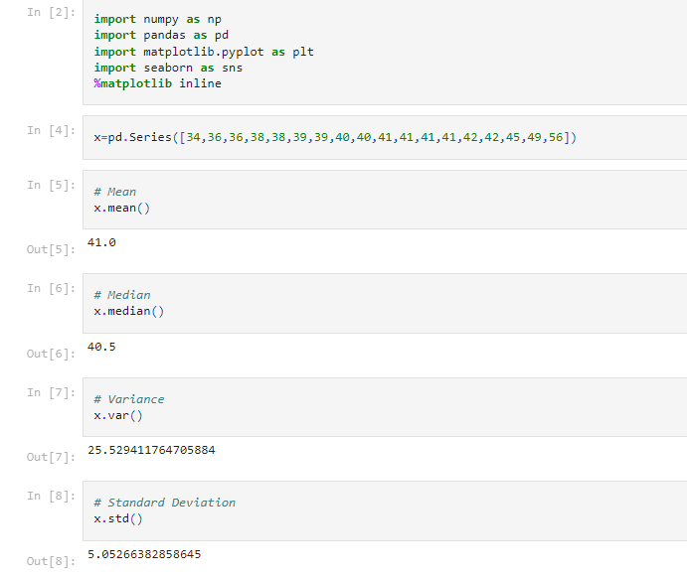

Average marks obtained by the students are 41 and 40.5 divides both 50% data on either side. There is large variation between lowest and highest marks.

**Q13)** What is the nature of skewness when mean, median of data are equal?

ANS: As distributions become more skewed the difference between these different measures of central tendency gets larger.

**Q14)** What is the nature of skewness when mean > median?

ANS: the mean and median can be used to figure out if you have a positively or negatively skewed distribution.

If the mean is greater than the median, the distribution is positively skewed.

**Q15)** What is the nature of skewness when median > mean?

ANS: If the mean is less than the median, the distribution is negatively skewed.

**Q16)** what does positive kurtosis value indicates for a data?

ANS: A distribution with a positive kurtosis value indicates that the distribution has heavier tails than the normal distribution. For example, data that follow a t distribution have a positive kurtosis value.

**Q17)** what does negative kurtosis value indicates for a data?

ANS: Negative values for the skewness indicate data that are skewed left and positive values for the skewness indicate data that are skewed right. By skewed left, we mean that the left tail is long relative to the right tail. Similarly, skewed right means that the right tail is long relative to the left tail.

**Q18)** Answer the below questions using the below boxplot visualization.



What can we say about the distribution of the data?

What is nature of skewness of the data?

What will be the IQR of the data (approximately)?

ANS: More data is distributed on the right side of the box plot so not normally distributed

Skewness is negative

IQR of data is 18-10=8  
  
  
**Q19)** Comment on the below Boxplot visualizations?



Draw an Inference from the distribution of data for Boxplot 1 with respect  
 Boxplot 2.

ANS: Boxplot 1 covers data with very less variation and boxplot 2 covers data with high variation compared with boxplot 1.

**Q 20)** Calculate probability from the given dataset for the below cases

Data _set: Cars.csv

Calculate the probability of MPG of Cars for the below cases.

MPG <- Cars$MPG

* 1. P(MPG>38)
  2. P(MPG<40)

c. P (20<MPG<50)

ANS:

1. : P(MPG>38) = 0.3475939251582705 = 34.75%
2. P(MPG<40) = 0.7293498762151616 = 72.93%
3. P (20<MPG<50) = 0.8988689169682046 = 89.88%

Refer file assignments.ipynb Q-20

**Q 21)** Check whether the data follows normal distribution

1. Check whether the MPG of Cars follows Normal Distribution

Dataset: Cars.csv

ANS:

Refer assignments.ipynb Q-21a

Skewness of MPG of cars: -0.1764

It means MPG of the cars is having negative skewness with more mass distributed on the right side so it does not follows normal distribution

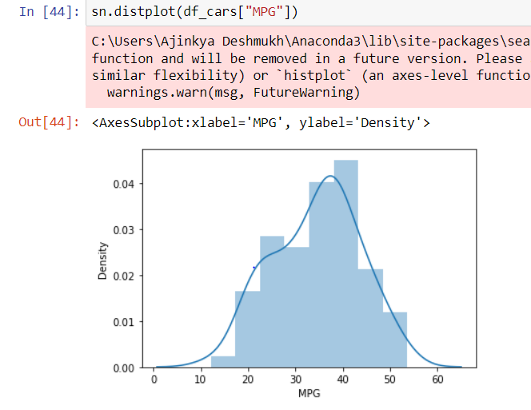

b. Check Whether the Adipose Tissue (AT) and Waist Circumference (Waist) from wc-at data set follows Normal Distribution

Dataset: wc-at.csv

ANS: Refer assignments.ipynb Q-21b

Skewness of Waist = 0.1322

It means Waist is having positive skewness with more mass distributed on the left side so it does not follows normal distribution (it is also clear from its shape from the python file)

Skewness of AT = 0.5767

It means AT is having positive skewness with more mass distributed on the left side so it does not follows normal distribution (it is also clear from its shape from the python file)

Waist Circumference (Waist) from wc-at data does not follows normal distribution and Adipose Tissue (AT) also not follows normal distribution as both are not symmetrical about the axis.

Refer below screenshots and refer file assignments.ipynb.

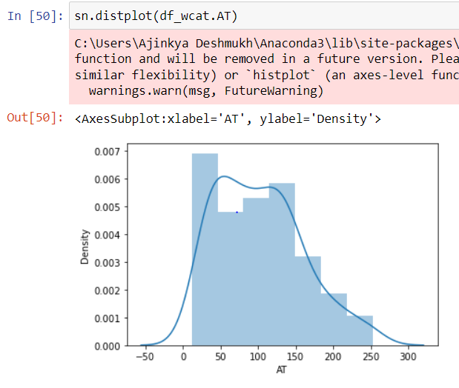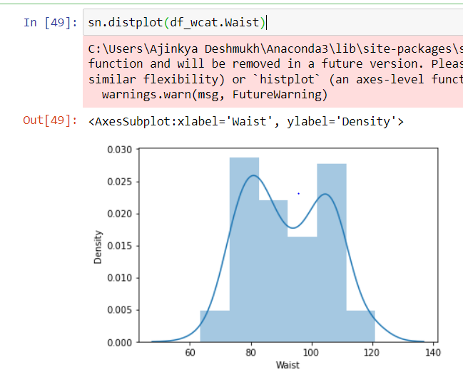

**Q 22)** Calculate the Z scores of 90% confidence interval,94% confidence interval, 60% confidence interval

ANS:

|  |  |
| --- | --- |
| Confidence Interval | Z score |
| 60% | 0.8416 |
| 90% | 1.6448 |
| 94% | 1.8807 |

Refer file assignments.ipynb – Q22

**Q 23)** Calculate the t scores of 95% confidence interval, 96% confidence interval, 99% confidence interval for sample size of 25

ANS:

|  |  |
| --- | --- |
| Confidence Interval | t score |
| 95% | 2.0638 |
| 96% | 2.1715 |
| 99% | 2.7969 |

Refer file assignments.ipynb – Q23

**Q 24)** A Government company claims that an average light bulb lasts 270 days. A researcher randomly selects 18 bulbs for testing. The sampled bulbs last an average of 260 days, with a standard deviation of 90 days. If the CEO's claim were true, what is the probability that 18 randomly selected bulbs would have an average life of no more than 260 days

Hint:

rcode 🡪 pt(tscore,df)

df 🡪 degrees of freedom

ANS: n= 18

u=270 days, s(sample deviation) = 90 days, xnbar = 260

P(u<=260) = 0.3216 or 32.16%

Refer file assignments.ipynb – Q24